**Spike:** 1

**Title:** Gridworld

**Author:** Will Truscott, 9992022

**Goals / deliverables:**

You will need to deliver the following items:

1. A simple paper-based plan for your code design. (Yes, a simple functional design is fine – just as long as you can demonstrate that you planned first before coding!)

2. Create a simple console program that implements the “GridWorld” game using a simple game loop. The game must demonstrate the separation of:

a. processing of input (text commands from the player),

b. updating of a game model (where the player is and their options),

c. display (output current location and options) of the game to the user.

3. Spike Outcome Report.

Note: The Spike Outcome Report is always a required “deliverable”. It will not be repeated in future spike requirements as it is assumed.

**Technologies, Tools, and Resources used:**

Visual Studio 2013

**Tasks undertaken:**

Designed it on paper, then created it. Find the implemented design below.

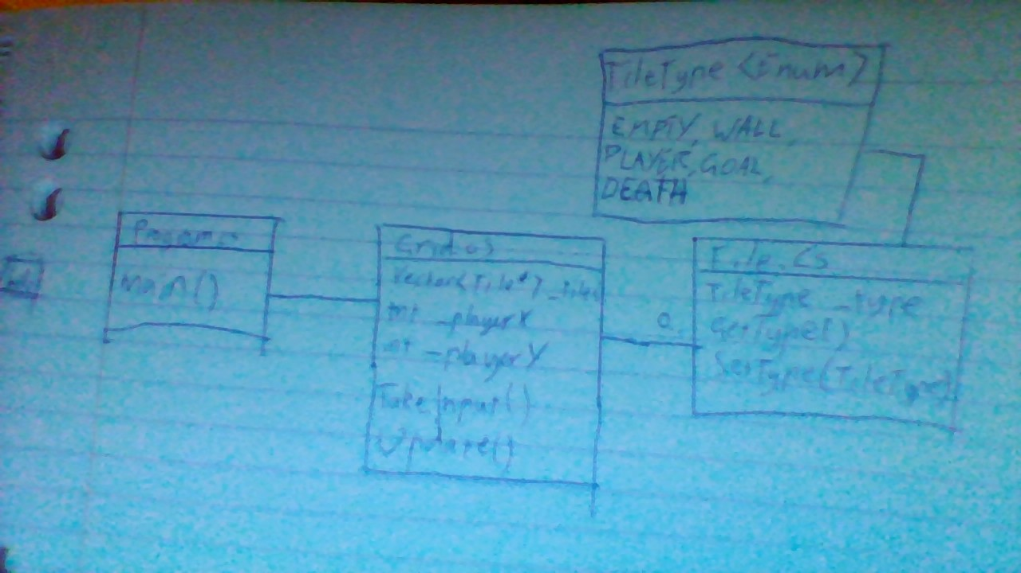

**What we found out:**

I re-familiarised myself with the C++ language.